Element:
element is a plain object describing what you want to appear on the screen in terms of the DOM nodes or other components. element is not an actual instance. element is a lightweight description of what to render.

it cannot be mutated.

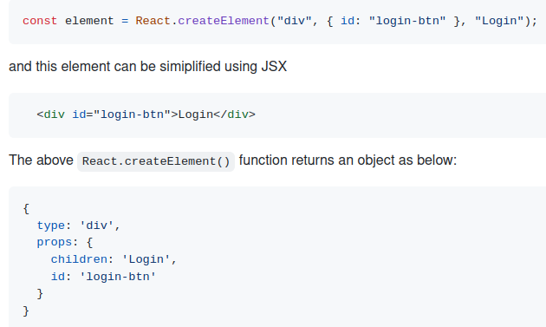

Component:
Components are the building blocks of creating User Interfaces(UI) in React.

Pure Components:
Pure components are the components which render the same output for the same state and props. In function components, you can achieve these pure components through memoized React.memo() API wrapping around the component. This API prevents unnecessary re-renders by comparing the previous props and new props using shallow comparison. So it will be helpful for performance optimizations.

State:
State of a component is an object that holds some information that may change over the lifetime of the component. The important point is whenever the state object changes, the component re-renders.

Props:
props is a special keyword in React, which stands for properties and is being used for passing data from one component to another. But the important part here is that data with props are being passed in a uni-directional flow. ( one way from parent to child).

Why should we not update the state directly?
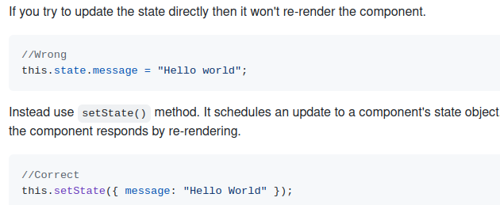

What is the purpose of callback function as an argument of setState()?
The callback function is invoked when setState finished and the component gets rendered. Since setState() is asynchronous the callback function is used for any post action.

setState({ name: "John" }, () =>
console.log("The name has updated and component re-rendered")
);

What is the difference between HTML and React event handling?

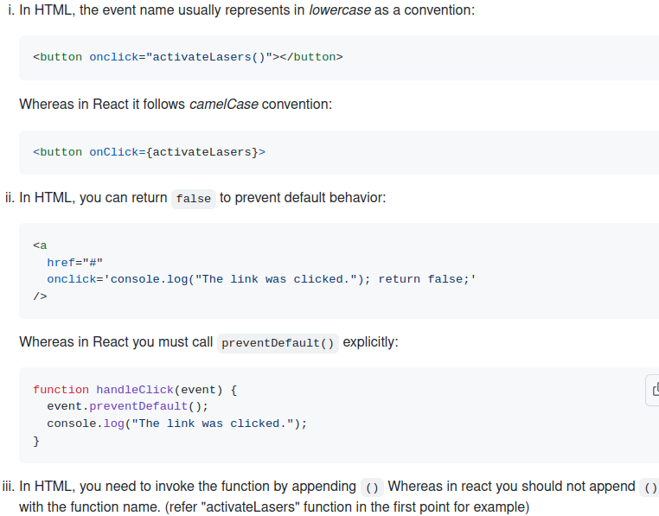
.

What is "key" prop and what is the benefit of using it in arrays of elements?
A key is a special attribute you should include when mapping over arrays to render data. Key prop helps React identify which items have changed, are added, or are removed.
Keys should be unique among its siblings. Most often we use ID from our data as key.

What are Higher-Order Components?
A higher-order component (HOC) is a function that takes a component and returns a new component. Basically, it's a pattern that is derived from React's compositional nature.

We call them pure components because they can accept any dynamically provided child component but they won't modify or copy any behavior from their input components.

What is reconciliation?
Reconciliation is the process through which React updates the Browser DOM and makes React work faster. React use a diffing algorithm so that component updates are predictable and faster. React would first calculate the difference between the real DOM and the copy of DOM (Virtual DOM) when there's an update of components. React stores a copy of Browser DOM which is called Virtual DOM. When we make changes or add data, React creates a new Virtual DOM and compares it with the previous one. This comparison is done by Diffing Algorithm. Now React compares the Virtual DOM with Real DOM. It finds out the changed nodes and updates only the changed nodes in Real DOM leaving the rest nodes as it is. This process is called Reconciliation.

What are error boundaries in React v16?
Error boundaries are components that catch JavaScript errors anywhere in their child component tree, log those errors, and display a fallback UI instead of the component tree that crashed. A class component becomes an error boundary if it defines a new lifecycle method called componentDidCatch(error, info) or static getDerivedStateFromError()

